1) Add Items and User Details

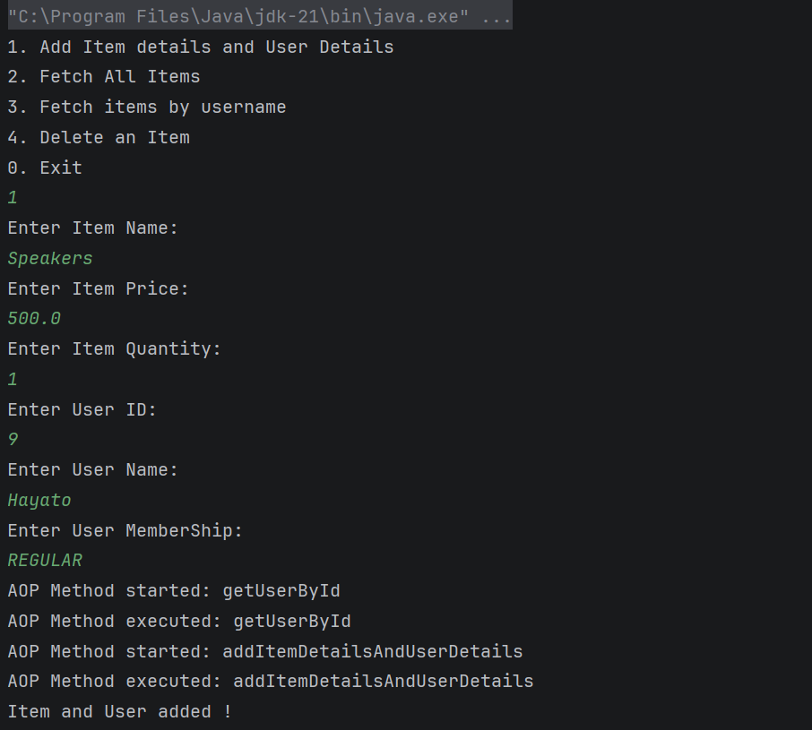

2 ) Fetch All Items
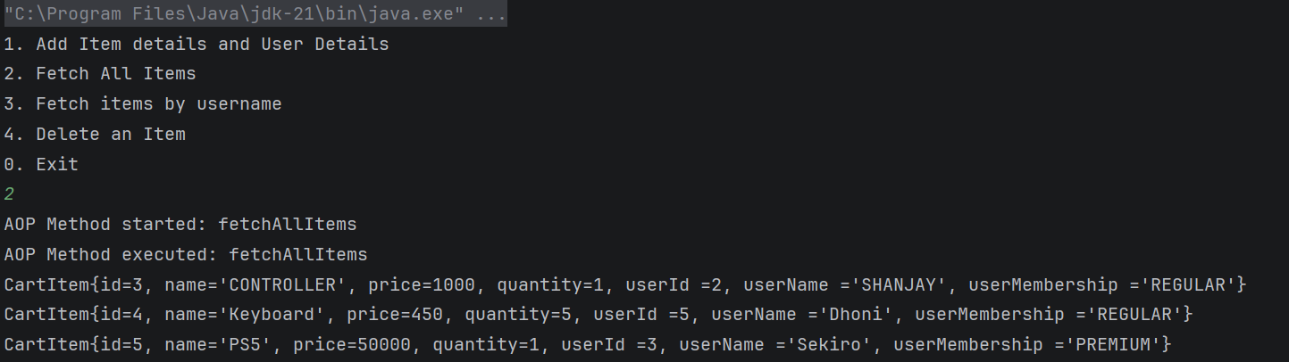

3 ) Fetch Items by Username
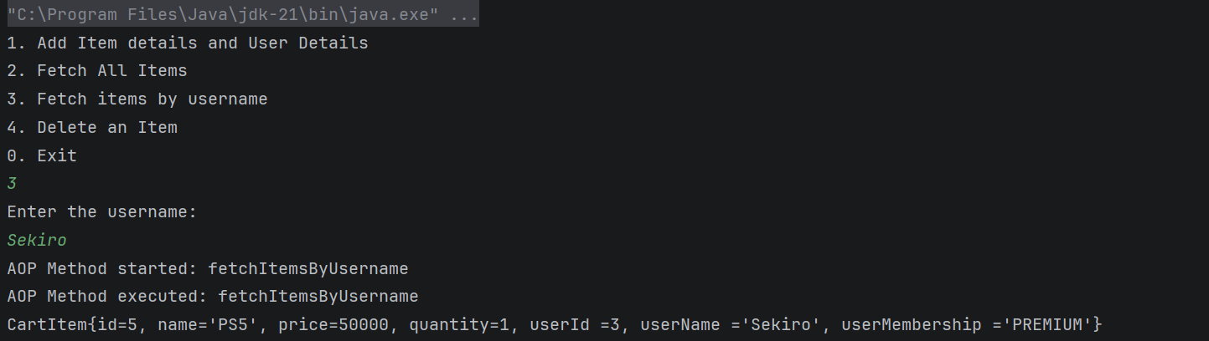

4)Delete Item
